SIMATS ENGINEERING

CO - 1 ASSESSMENT TOOL 1 – High (Coding Challenge)

COURSE CODE: CSA0911

COURSE NAME: Programming in Java

COURSE OUTCOME COVERED

NAME: N. NAVEENKUMAR
REG NO: 192372341

1.
import java.util.Scanner;

class Book {
private int bookId;
private String title;
private String author;
private double price;
private boolean issued;

Book(int id, String t, String a, double p) {
bookId = id;
title = t;
author = a;
price = p;
issued = false;
}

int getBookId() {
return bookId;
}

void issue() {
if (!issued) {
issued = true;
System.out.println("Book Issued");
} else {
System.out.println("Already Issued");
}
}
void returnBook() {
issued = false;
System.out.println("Book Returned");
}
void display() {
System.out.println(bookId + " " + title + " " + author + " " + price);
}
public static void main(String[] args) {
Scanner sc = new Scanner(System.in);

Book[] books = new Book[5];
int count = 0;

while (true) {
System.out.println("\n1.Add 2.Display 3.Issue 4.Return 5.Search 6.Exit");
int ch = sc.nextInt();

if (ch == 1) {
System.out.print("ID: ");
int id = sc.nextInt();
sc.nextLine();

System.out.print("Title: ");
String title = sc.nextLine();

System.out.print("Author: ");
String author = sc.nextLine();

System.out.print("Price: ");
double price = sc.nextDouble();

books[count++] = new Book(id, title, author, price);
System.out.println("Book Added");
}
else if (ch == 2) {
for (int i = 0; i < count; i++)
books[i].display();
}
else if (ch == 3) {
System.out.print("Book ID: ");
int id = sc.nextInt();

for (int i = 0; i < count; i++)
if (books[i].getBookId() == id)
books[i].issue();
}
else if (ch == 4) {
System.out.print("Book ID: ");
int id = sc.nextInt();
for (int i = 0; i < count; i++)
if (books[i].getBookId() == id)
books[i].returnBook();
}
else if (ch == 5) {
System.out.print("Book ID: ");
int id = sc.nextInt();
for (int i = 0; i < count; i++)
if (books[i].getBookId() == id)
books[i].display();
}
else
break;
}
}
}
Output:
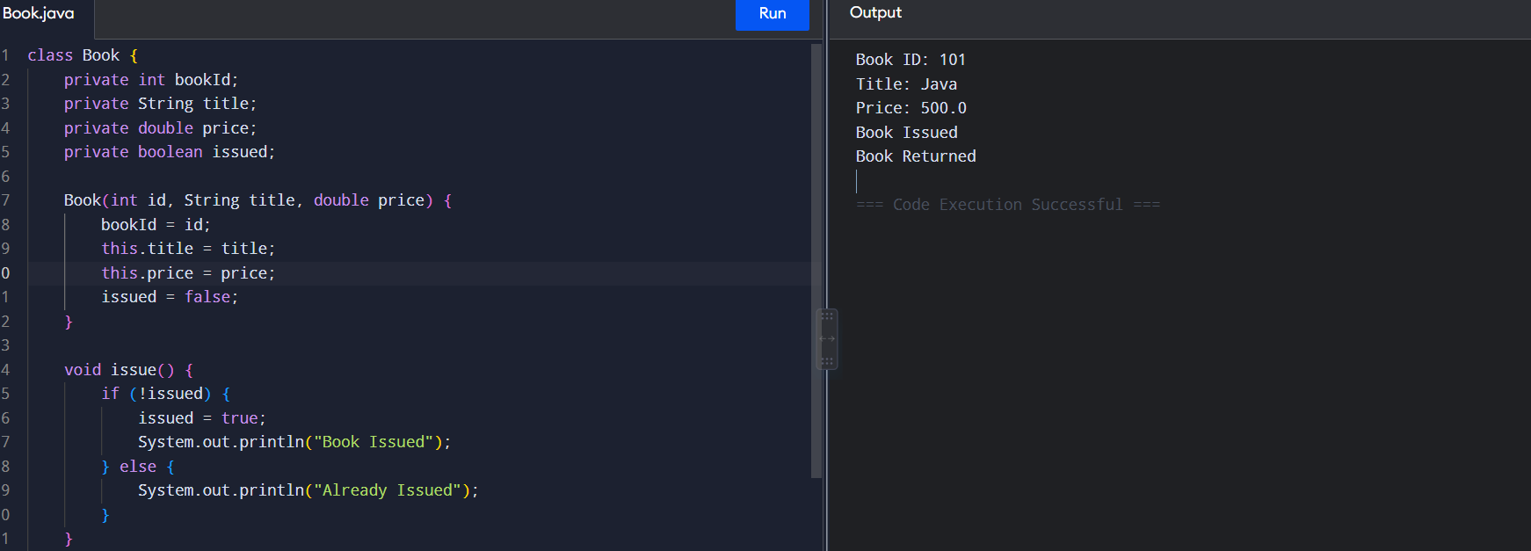

2.
class Employee {
String name;

Employee(String name) {
this.name = name;
}

double calculateSalary() {
return 0;
}

public static void main(String[] args) {
Employee e;

e = new PermanentEmployee("Naveen", 30000);
System.out.println(e.name);
System.out.println("Salary: " + e.calculateSalary());

e = new ContractEmployee("Rahul", 20000);
System.out.println(e.name);
System.out.println("Salary: " + e.calculateSalary());
}
}

class PermanentEmployee extends Employee {
double salary;

PermanentEmployee(String name, double salary) {
super(name);
this.salary = salary;
}

double calculateSalary() {
return salary + salary * 0.20;
}
}

class ContractEmployee extends Employee {
double salary;

ContractEmployee(String name, double salary) {
super(name);
this.salary = salary;
}

double calculateSalary() {
return salary;
}
}

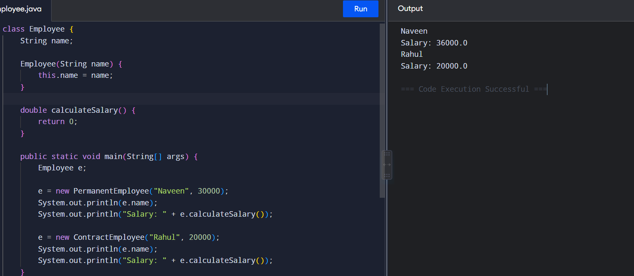


3.
class Vehicle {
double calculateRent(int days) {
return 0;
}

public static void main(String[] args) {
Vehicle[] v = {
new Car(),
new Bike(),
new Bus()
};

int days = 2;

for (Vehicle x : v)
System.out.println(x.calculateRent(days));
}
}

class Car extends Vehicle {
@Override
double calculateRent(int days) {
return days * 1500;
}
}

class Bike extends Vehicle {
@Override
double calculateRent(int days) {
return days * 500;
}
}

class Bus extends Vehicle {
@Override
double calculateRent(int days) {
return days * 3000;
}
}

OUTPUT:
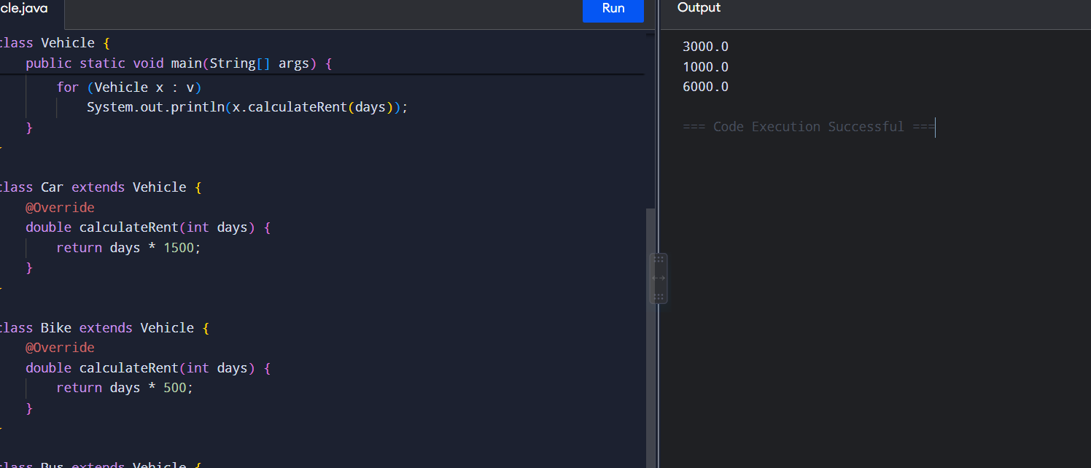

4.
class BankAccount {
private int accountNumber;
private String holderName;
private double balance;

BankAccount(int no, String name, double balance) {
accountNumber = no;
holderName = name;
this.balance = balance;
}

void deposit(double amount) {
if (amount > 0)
balance += amount;
else
System.out.println("Invalid Deposit");
}

void withdraw(double amount) {
if (amount > 0 && amount <= balance)
balance -= amount;
else
System.out.println("Invalid Withdrawal");
}

void display() {
System.out.println("Account: " + accountNumber);
System.out.println("Name: " + holderName);
System.out.println("Balance: " + balance);
}

public static void main(String[] args) {
BankAccount b = new BankAccount(101, "Naveen", 5000);

b.deposit(2000);
b.withdraw(1000);
b.display();
}
}
OUTPUT:

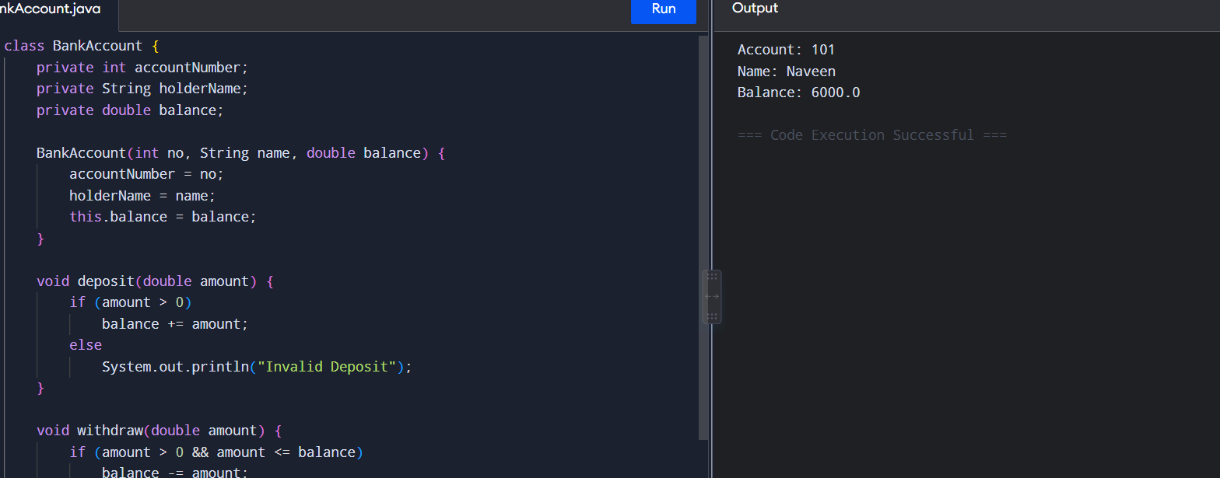

5
class Admission {

double calculateFee(double fee) {
return fee;
}

double calculateFee(double fee, boolean pg) {
return fee + 5000;
}

double calculateFee(double fee, double scholarship) {
return fee - scholarship;
}

public static void main(String[] args) {
Admission a = new Admission();

System.out.println("UG Fee = " + a.calculateFee(50000));
System.out.println("PG Fee = " + a.calculateFee(60000, true));
System.out.println("Scholarship Fee = "
+ a.calculateFee(50000, 10000));
}
}

OUTPUT:

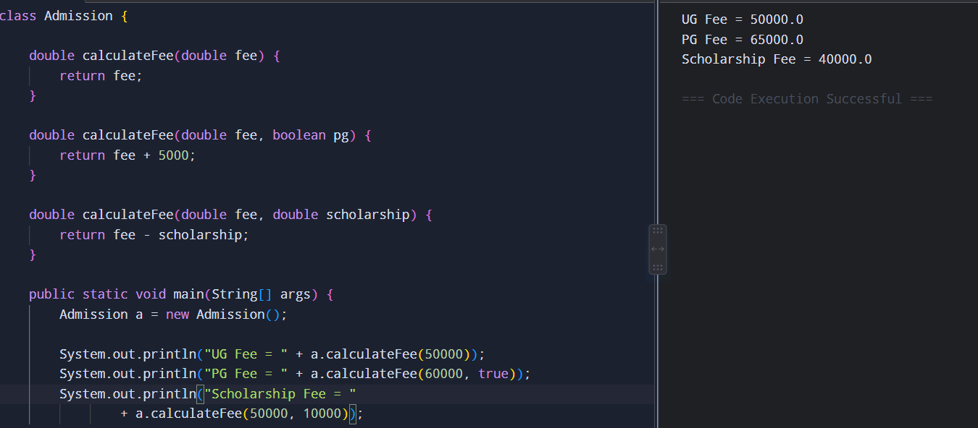

6.
abstract class Shape {

abstract double area();

public static void main(String[] args) {
Shape[] s = {
new Circle(5),
new Rectangle(10, 5),
new Triangle(10, 5)
};

for (Shape x : s)
System.out.println("Area = " + x.area());
}
}

class Circle extends Shape {
double r;

Circle(double r) {
this.r = r;
}

double area() {
return 3.14 * r * r;
}
}

class Rectangle extends Shape {
double l, w;

Rectangle(double l, double w) {
this.l = l;
this.w = w;
}

double area() {
return l * w;
}
}

class Triangle extends Shape {
double b, h;

Triangle(double b, double h) {
this.b = b;
this.h = h;
}

double area() {
return 0.5 * b * h;
}
}

OUTPUT :
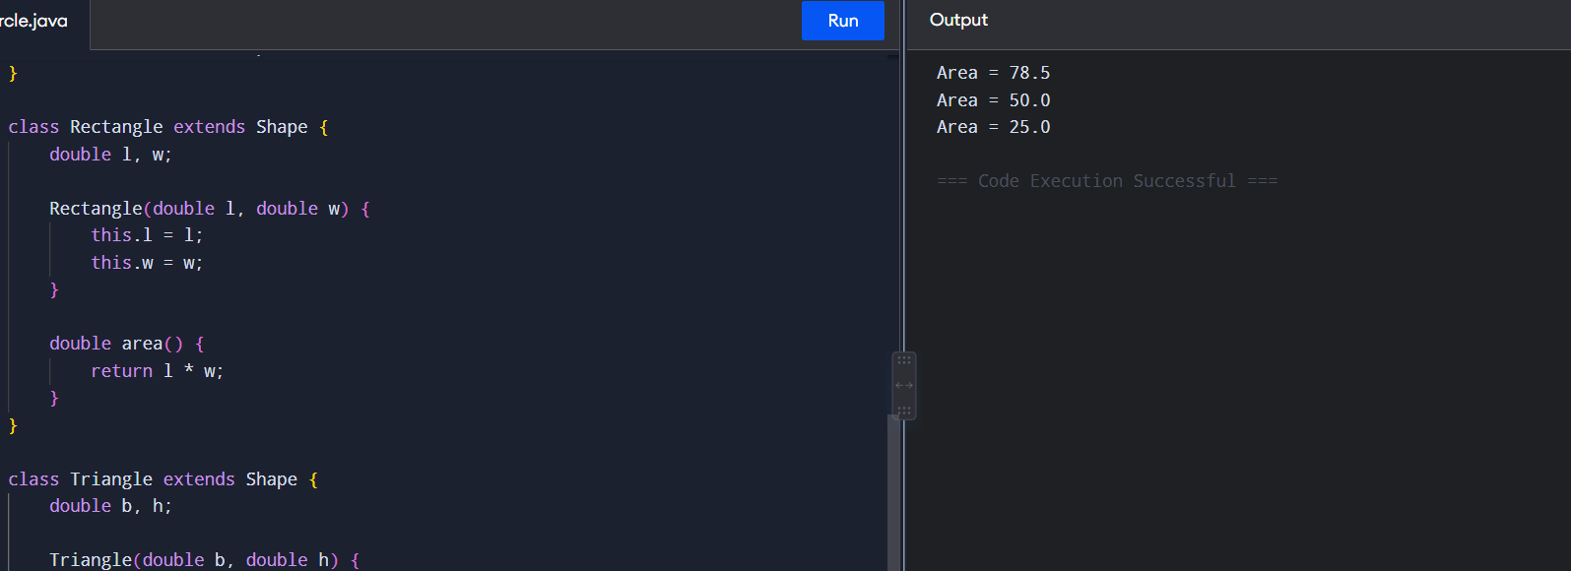

7.

interface MedicalRecord {

void addRecord();
void displayRecord();

public static void main(String[] args) {

MedicalRecord p = new Patient();
p.addRecord();
p.displayRecord();

MedicalRecord d = new Doctor();
d.addRecord();
d.displayRecord();
}
}

class Patient implements MedicalRecord {

String name = "Naveen";

public void addRecord() {
System.out.println("Patient Record Added");
}

public void displayRecord() {
System.out.println("Patient Name: " + name);
}
}

class Doctor implements MedicalRecord {

String name = "Dr. Kumar";

public void addRecord() {
System.out.println("Doctor Record Added");
}

public void displayRecord() {
System.out.println("Doctor Name: " + name);
}
}
OUPTUT :
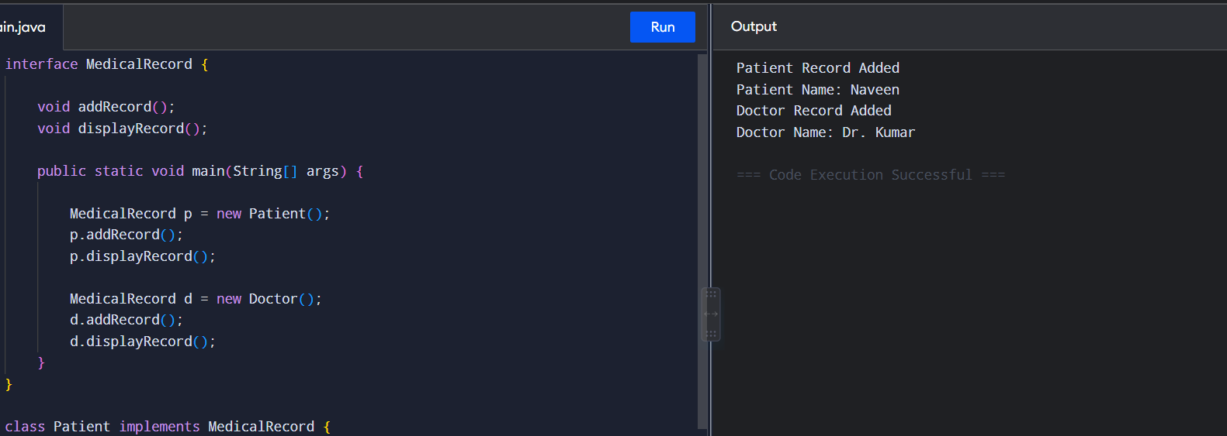

8.
class Product {
String name;
double price;

Product(String name, double price) {
this.name = name;
this.price = price;
}
}

class Order {
void bill(Product p, int quantity) {
double total = p.price * quantity;

System.out.println("Product: " + p.name);
System.out.println("Quantity: " + quantity);
System.out.println("Total: " + total);
}
}

public class Main {
public static void main(String[] args) {

Product p = new Product("Laptop", 50000);

Order o = new Order();
o.bill(p, 2);
}
}
OUTPUT :
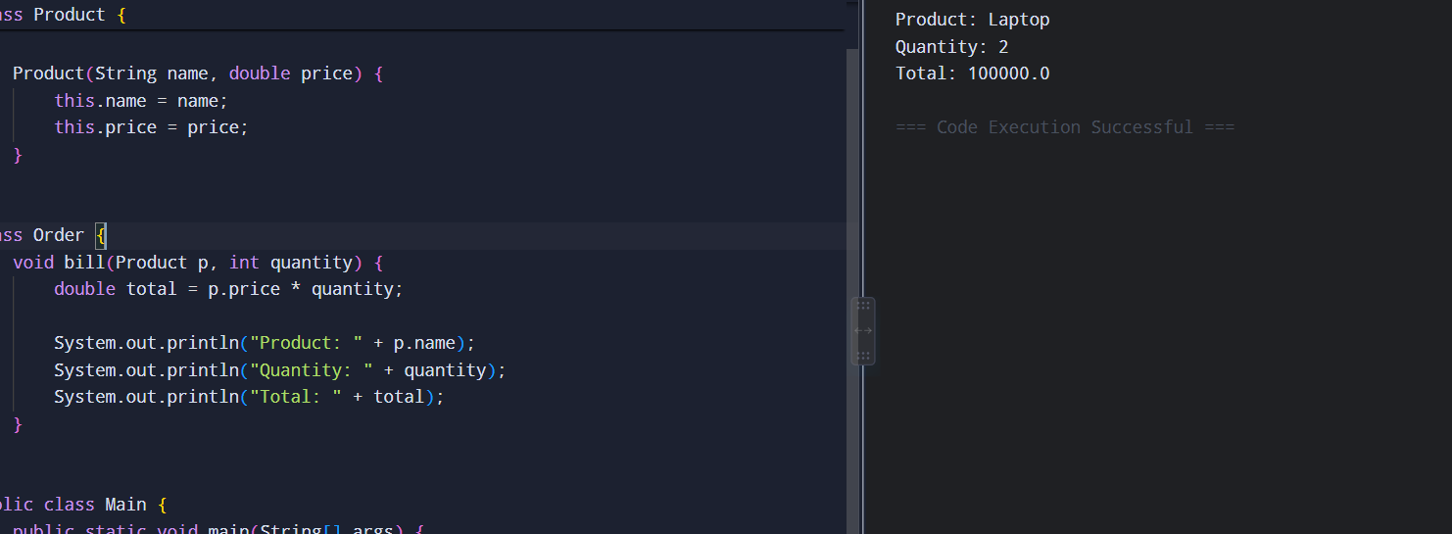

9.
class Student {
int roll;
String name;
int m1, m2, m3;

Student(int roll, String name, int m1, int m2, int m3) {
this.roll = roll;
this.name = name;
this.m1 = m1;
this.m2 = m2;
this.m3 = m3;
}

int total() {
return m1 + m2 + m3;
}

double average() {
return total() / 3.0;
}

char grade() {
double a = average();

if (a >= 90)
return 'A';
else if (a >= 75)
return 'B';
else if (a >= 60)
return 'C';
else if (a >= 50)
return 'D';
else
return 'F';
}

void display() {
System.out.println(name + " Total=" + total()
+ " Average=" + average()
+ " Grade=" + grade());
}

public static void main(String[] args) {

Student[] s = {
new Student(1, "Naveen", 90, 85, 95),
new Student(2, "Rahul", 70, 75, 80),
new Student(3, "Arun", 95, 90, 98)
};

int topper = 0;

for (int i = 0; i < s.length; i++) {
s[i].display();

if (s[i].total() > s[topper].total())
topper = i;
}

System.out.println("Topper: " + s[topper].name);
}
}
OUTPUT :

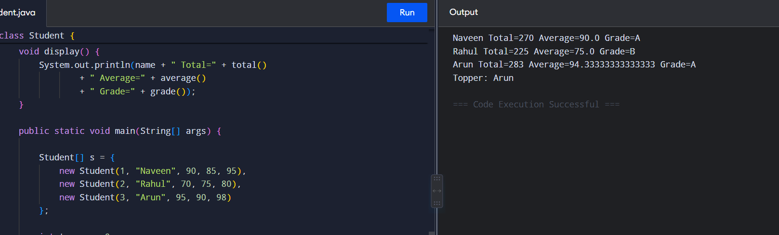
10.
class Device {

void turnOn() {
System.out.println("Device ON");
}

void turnOff() {
System.out.println("Device OFF");
}

void power() {
System.out.println("Power consumption");
}

public static void main(String[] args) {

Device[] d = {
new Light(),
new Fan(),
new AirConditioner()
};

for (Device x : d) {
x.turnOn();
x.power();
x.turnOff();
System.out.println();
}
}
}

class Light extends Device {
void power() {
System.out.println("Light: 20W");
}
}

class Fan extends Device {
void power() {
System.out.println("Fan: 75W");
}
}

class AirConditioner extends Device {
void power() {
System.out.println("AC: 1500W");
}
}

OUTPUT :

